**Deploying jar file into tomcat server using Jenkins-Pipeline**

**Create 2 ec2-instances with t2.micro**

Jenkins server ip : root@ip-172-31-27-249

Application-server ip : root@ip- 172-31-25-171

**Install Jenkins in Jenkins server**

* Yum install java-1.8* -y
* curl --silent --location http://pkg.jenkins-ci.org/redhat-stable/jenkins.repo | sudo tee /etc/yum.repos.d/jenkins.repo
* sudo rpm --import <https://jenkins-ci.org/redhat/jenkins-ci.org.key>
* yum install Jenkins
* sudo systemctl start jenkins.service
* sudo systemctl enable jenkins.service

**Install git in Jenkins server**

* Yum install git -y

**Install tomcat in application server**

* Yum install java-1.8* -y
* Cd /opt
* Wget <http://mirrors.estointernet.in/apache/tomcat/tomcat-9/v9.0.30/bin/apache-tomcat-9.0.30.tar.gz>
* Tar –xvf apache-tomcat-9.0.30
* mv apache-tomcat-9.0.30 tomcat9

->Start the Jenkins service

->Allow traffic 8080 in both servers

Goto manage Jenkins 🡪 global tool configuration

Install maven

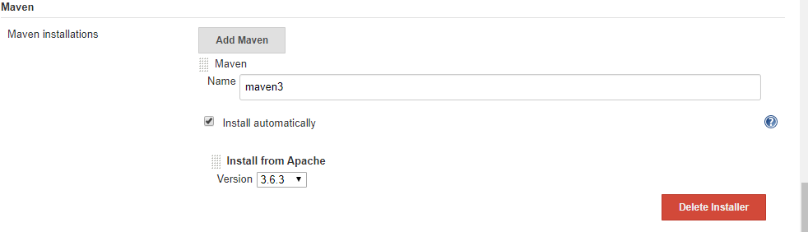

Configure the github credentials in crendentials->select global->Add crendentials

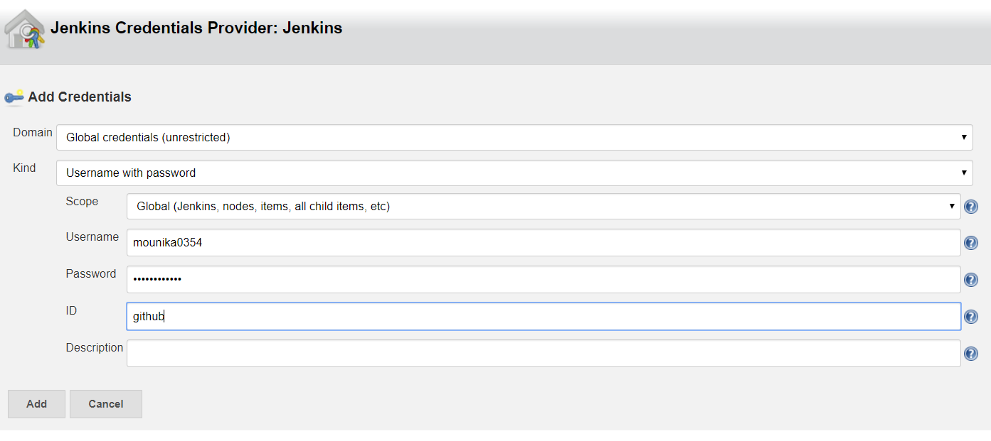

Here we no need to write full script .By default Jenkins is providing some sample pipeline scripts.

To work with that scripts just click on Pileline Syntax

For git we have to follow like this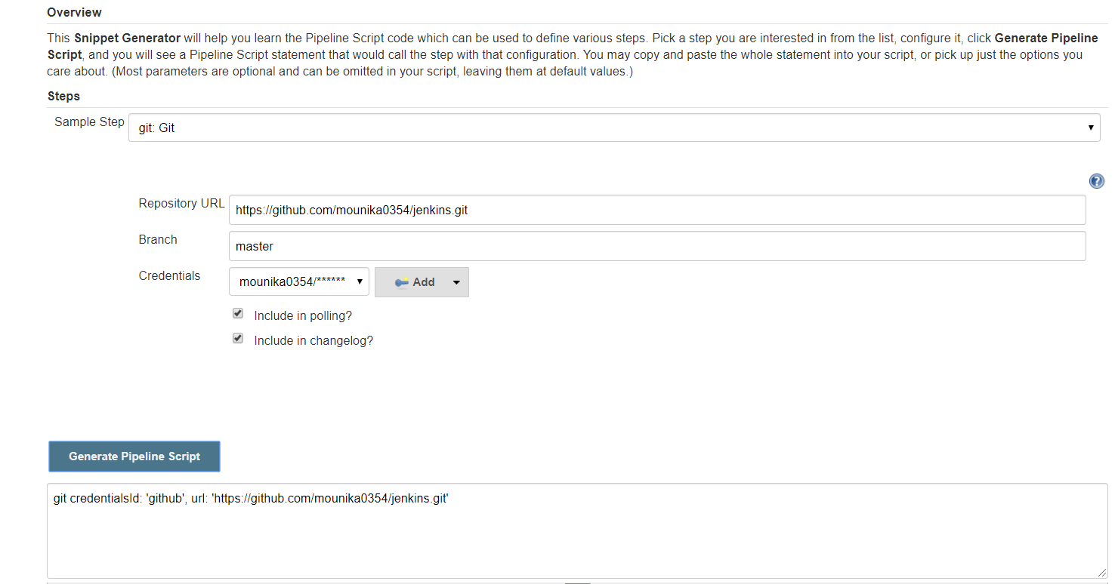

For maven we have to follow like this

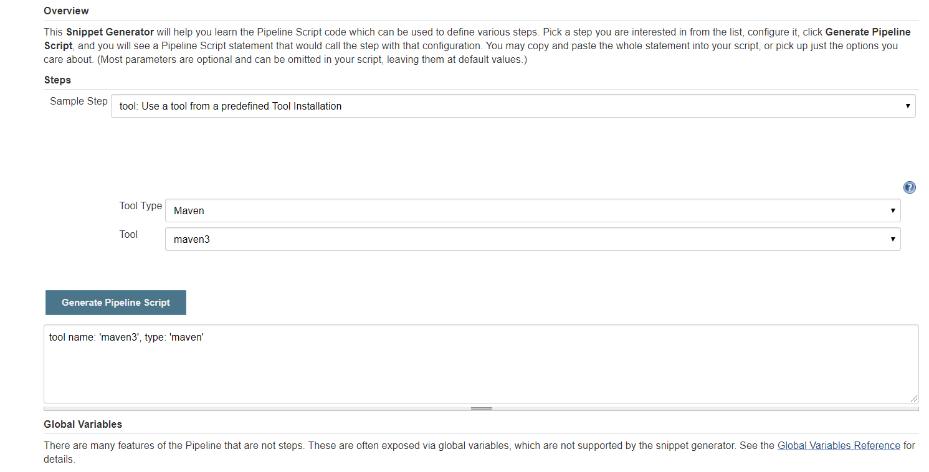

Install ssh agent and ssh plugin in Jenkins server

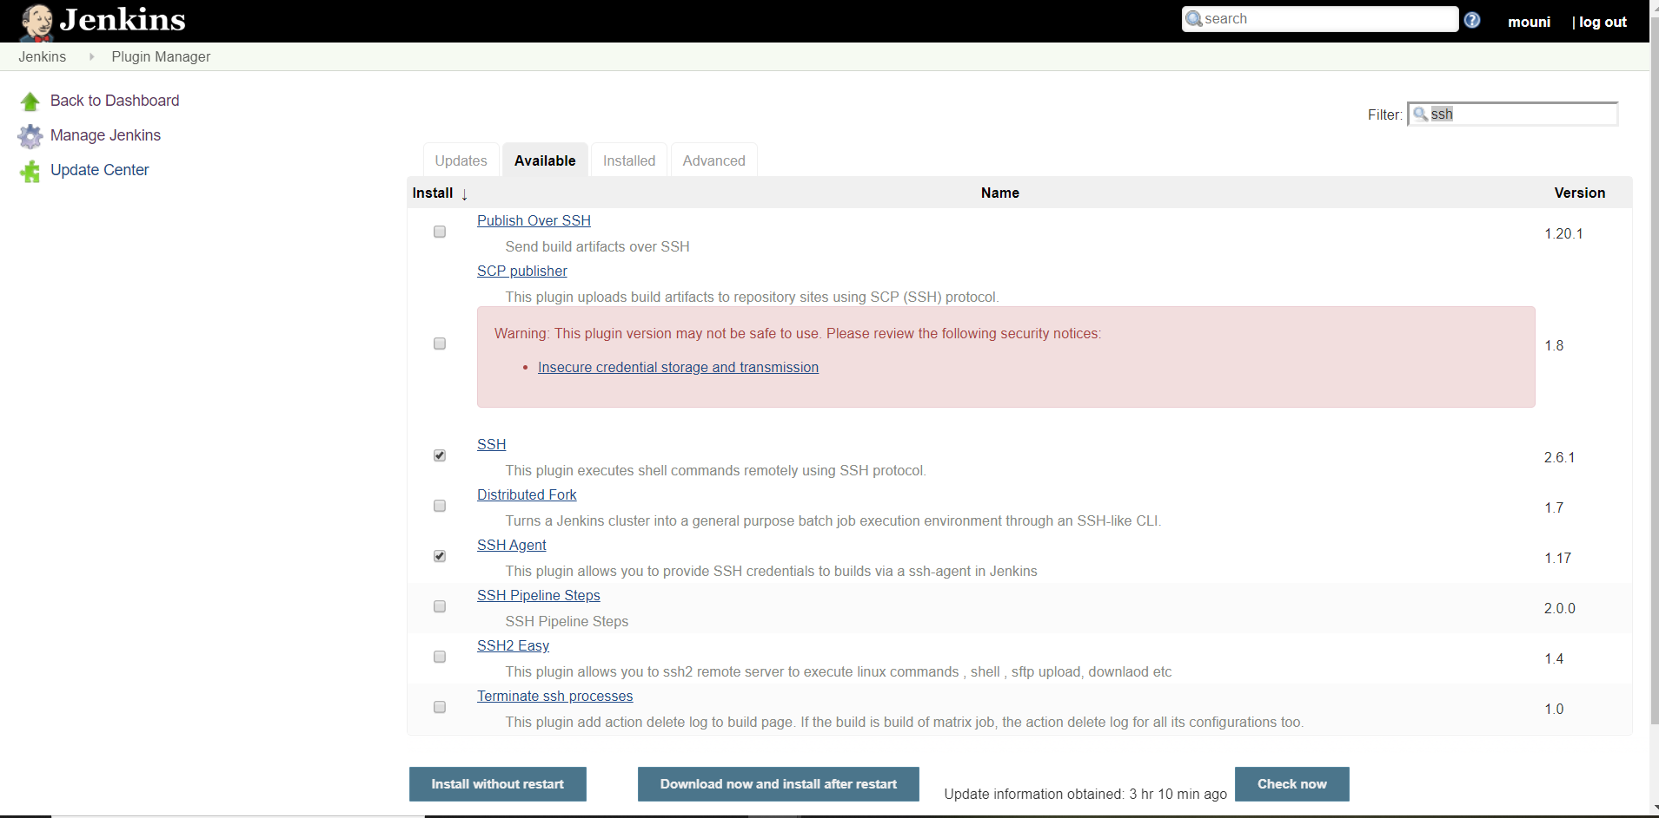

Add the credentials of application –server in crendentials->select global->Add crendentials 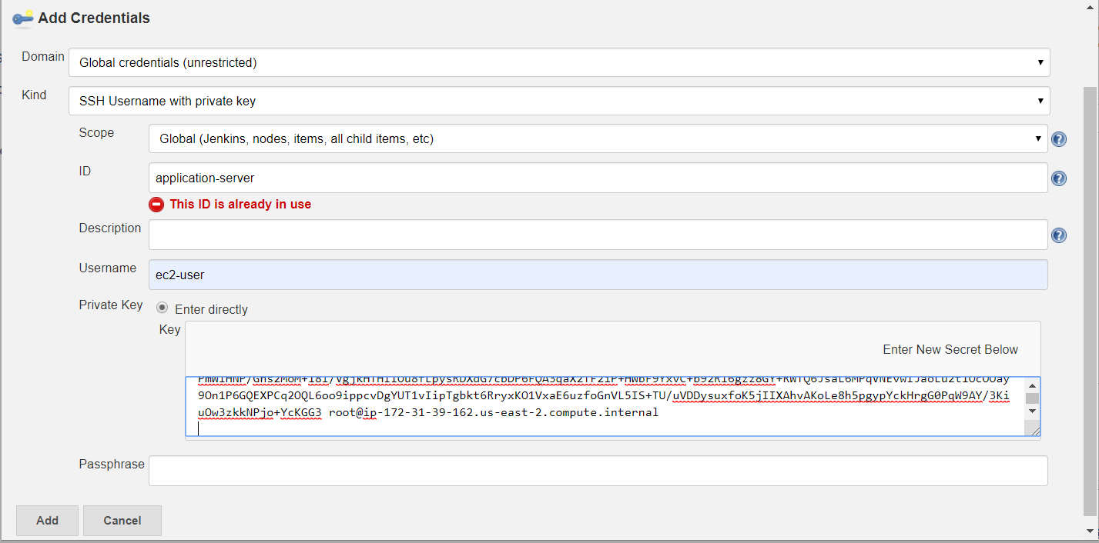

For ssh agent key copy the pemfile of Application-server

Go to Configure system -> select ssh remote hosts->

* Host name: Application-server ip
* Port : 22
* Credentials : select application-server credentials

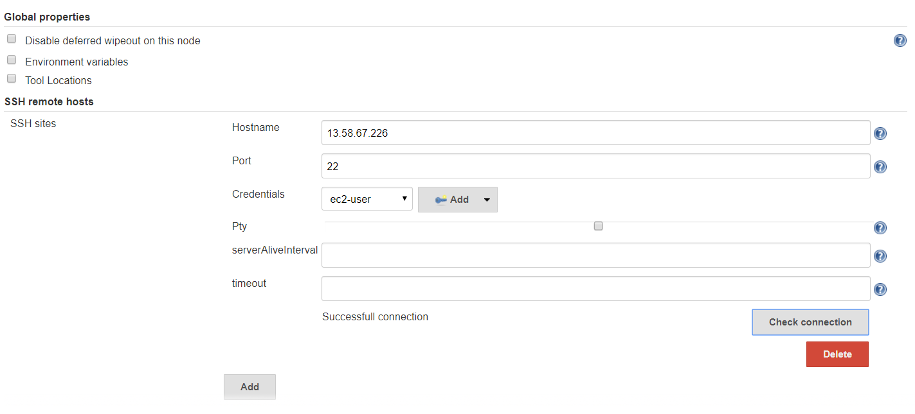

For sshagent we have to follow like this

* Sample step : sshagent SSH Agent
* Add the credentials of application server

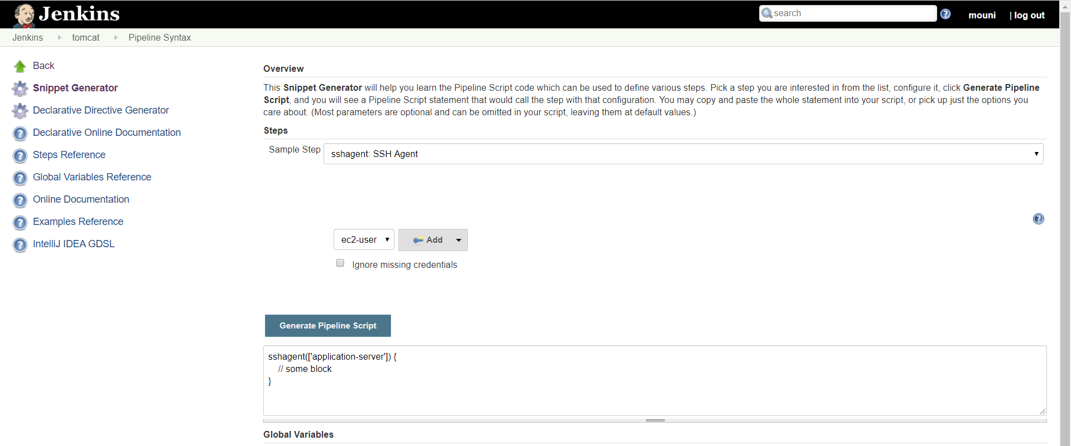

Go to Application server give ownership permission for ec2-user to tomcat9

Chown –R ec2-user:ec2-user tomcat9

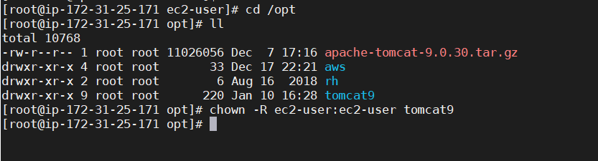

Now we can check our jar file in webapps folder

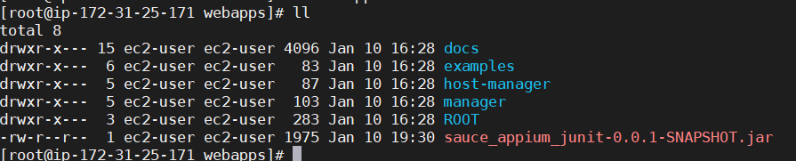

Pipeline-job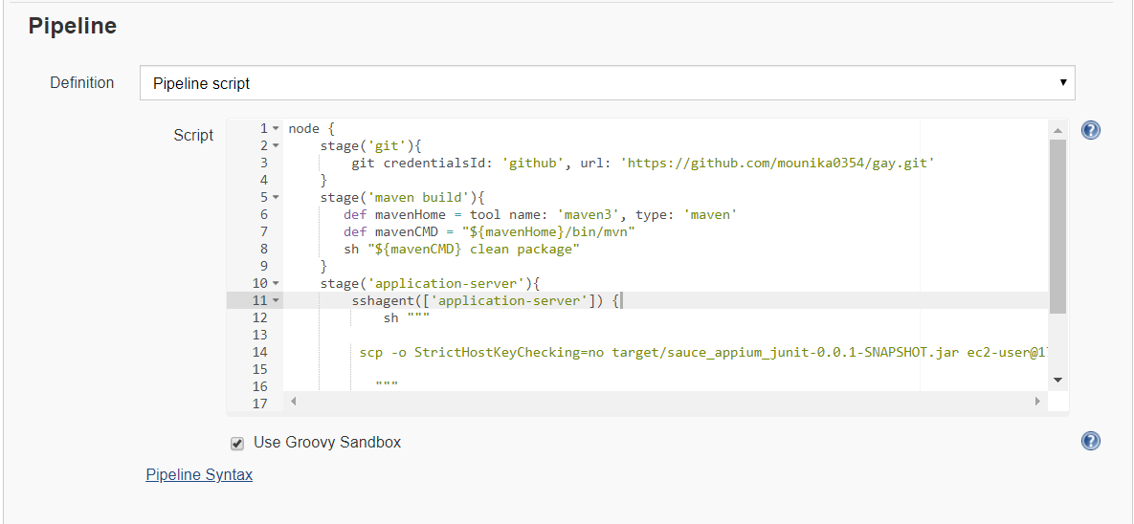

####################SCRIPT###################

*node {*

*stage('git'){*

*git credentialsId: 'github', url: 'https://github.com/mounika0354/gay.git'*

*}*

*stage('maven build'){*

*def mavenHome = tool name: 'maven3', type: 'maven'*

*def mavenCMD = "${mavenHome}/bin/mvn"*

*sh "${mavenCMD} clean package"*

*}*

*stage('application-server'){*

*sshagent(['application-server']) {*

*sh """*

*scp -o StrictHostKeyChecking=no target/sauce_appium_junit-0.0.1-SNAPSHOT.jar ec2-user@172.31.25.171:/opt/tomcat9/webapps*

*"""*

*}*

*}*

*}*